10 Editors - 3D View - Properties Sidebar
Detailed Table of content 1
Introduction 6
Properties Sidebar 6
Grease Pencil Layers Panel 6
Grease Pencil Colors Panel 10
View panel 12
3D Cursor Panel 14
Viewport Display Panel 14
Object Shading Panel 16
Motion Tracking Panel 19
Background Images Panel 19
Transform Orientations Panel 22
Important Hotkeys Panel 23
Item Panel 24
Stroke Select Panel 24
Transform Panel 24
Mesh Display Panel 28
Mesh Analysis Panel 30
Curve Display Panel 31
Skeleton Sketching Panel 31

Detailed Table of content

3.1.3 - 3D View by tools - Properties Sidebar
Detailed Table of content 1
Introduction 6
Properties Sidebar 6
Grease Pencil Layers Panel 6
Scene / Object 7
Grease Pencil Prop 7
New Layer 7
Layer list 7
Add / Delete 8
Layer Specials menu 8
Duplicate Layer 8
Show All 8
Hide Others 8
Lock All 8
Unlock All 8
Merge Down 8
Move Up / Move down 8
Lock Unlock unselected / Show Hide unselected 8
Opacity 8
X Ray 9
Show Points 9
Tint 9
Parent 9
Thickness Change 9
Lock Frame 9
Onion Skinning 10
Onion Skinning checkbox 10
Use always ghosts 10
Use custom colors 10
Before 10
After 10
Grease Pencil Colors Panel 10
GP Palette 10
Color List 11
Add / Delete 11
Palette color Specials menu 11
Show All 11
Hide Others 11
Lock All 11
Unlock All 11
Copy color 11
Select strokes 11
Move to color 11
Strokecolor 12
Volumetric Strokes 12
Fill 12
High Quality Fill 12
View panel 12
Lens 13
Clip 13
Render border 13
Lock section 13
Lock Camera to view 13
Lock Camera and Layers 13
Lock to Object 14
Lock to cursor 14
3D Cursor Panel 14
Lock 3D cursor 14
Show 3D Cursor 14
Viewport Display Panel 14
Icons or Text Buttons 15
Only Render 15
Ground Grid 15
Grid Floor 15
Grid Floor Checkbox 15
X, Y Z buttons 15
Lines 15
Scale 15
Subdivisions 15
Miscellaneous subtab 15
World Background 15
Outline Selected 16
All Object Origins 16
Relationship Lines 16
Object Shading Panel 16
Shading Options 16
Backface Culling 16
Depth of Field 16
Ambient Occlusion 16
Shadeless 16
Textured solid 17
Matcap 17
Wireframe Colors Subtab 17
Wire Color Set 17
Wire colors 17
Custom color set 18
Wire Tools Subtab 18
Wire Selection (Auto) 18
Only Selection 18
Invert 18
Wire + Edges 18
Wire 18
Hide All 18
Only Bounds 18
Textured 19
Motion Tracking Panel 19
Camera Path 19
3D Marker Names 19
Track Type and Size 19
Background Images Panel 19
Add Image 19
Image Panel 19
Image Panel Header 20
Data Source 20
Image Edit Box 20
Settings Subtab 20
Opacity 20
Axis 20
Source 20
Single Image 20
Image Sequence and Movie 20
Frames 20
Start 21
Offset 21
Match Movie Length 21
Auto Refresh 21
Cyclic 21
Generated 21
Color Space 21
View as Render 21
Size edit boxes 21
Float Buffer 21
Type 21
Align Subtab 22
Back / Front 22
Stretch / Fit / Crop 22
Offset Editboxes 22
Flip Horizontal 22
Flip Vertical 22
Rotation 22
Size 22
Transform Orientations Panel 22
Dropdown Box with the current views. 23
Create Orientation 23
Transform Orientation Name 23
Last Operator Create Orientation 23
Name 23
Use View 23
Use after creation 23
Overwrite previous 23
Important Hotkeys Panel 23
Show Text / Hide Text 23
Color 23
Fontsize 24
Item Panel 24
Stroke Select Panel 24
Transform Panel 24
In Object Mode 24
Location 24
Rotation 24
Rotation mode 24
Scale 25
Dimensions 25
In Edit Mode 25
Mesh Objects 25
Median 25
Global / Local 25
Mean Bevel Weight - Vertices Data 25
Mean Bevel Weight - Edges Data 25
Mean Crease 25
Curve Objects / Surface Objects 25
Median 25
Global / Local 26
Mean Weight 26
Mean Radius 26
Mean Tilt 26
Metaball Objects 26
Median 26
Global / Local 26
Radius 26
Stiffness 26
Type 26
Text Objects 26
Armature objects Edit Mode 26
Head 27
Radius 27
Tail 27
Radius 27
Roll 27
Envelope 27
Armature Objects in Pose Mode 27
Lattice Objects 27
Vertex 27
Global / Local 27
Mean Weight 28
Mesh Display Panel 28
Normals 28
Overlay Options subtab 28
Faces 28
Edges 28
Creases 28
Seams 28
Show Weights 28
Sharp 28
Bevel 28
Edge Marks 29
Face Marks 29
Info Options subtab 29
Edge Info 29
Length 29
Angle 29
Face Info 29
Area 29
Angle 29
Indices 29
Mesh Analysis Panel 30
Type dropdown box 30
Overhang 30
Thickness 30
Intersections 30
Distortion 30
Sharp Edges 30
Angle 31
Axis 31
Curve Display Panel 31
Handles 31
Normals 31
Normal Size 31
Skeleton Sketching Panel 31
Quick Sketching 32
Overdraw Sketching 32
Stroke Conversion method 32
Retarget 32
Adaptive 32
Length 32
Fixed 32
Convert to bones 32
Delete Strokes 32

Introduction

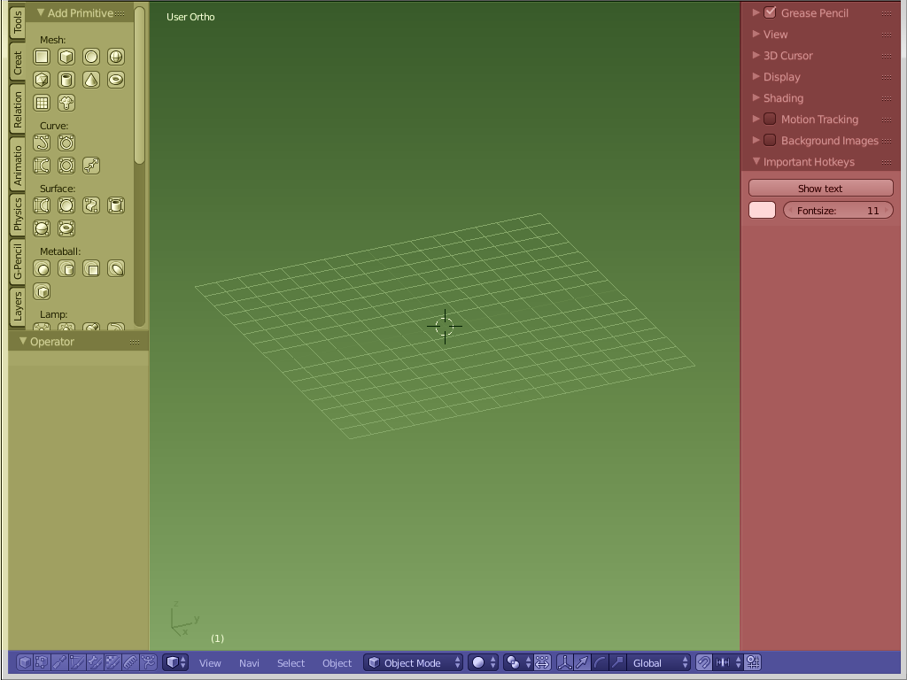
The 3D View is made of several areas.

Yellow is the Tool Shelf.
Blue is the Header or Menu bar. It can be at the top or the bottom.

Green is the Viewport. Here you will see and work with your 3D data.

Red is the Properties Sidebar.

The content of the Tool Shelf , the Header and the Properties Sidebar can vary. It depends of the type of the objects and the modes that you are in.

This chapter here is about the Properties Sidebar.

Properties Sidebar
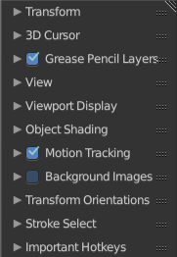
The Properties Sidebar contains various settings for the 3d view.

The Properties Sidebar is made of several panels. The range goes from object related settings, Grease Pencil settings, across things like Motion Tracking settings, Background Image settings, up to to Viewport related settings.

Most panels shows in all modes and with all content. Some Panels and its content is varying dependant of what object type you use, and in what object mode you are.

Grease Pencil Layers Panel
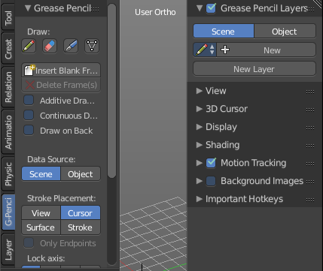
The Grease Pencil Layers are connected with the Grease Pencil panel in the Tool Shelf. And provides you with the layer settings for the Grease Pencil.
When no layer exists then there are just a few buttons available.

Scene / Object
Here you can adjust if the Grease Pencil stroke is relative to the selected object, or relative to the Screen.

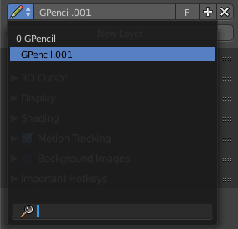
Grease Pencil Prop
Here you can add a new grease pencil to work with. Or choose an existing grease pencil.
The edit box allows you to rename the current grease pencil.
The F Button adds a fake user to the grease pencil. So that it does not get deleted when you delete the connected object and close the scene.
When you add a fake user, then a number field will appear that shows how much users are connected with the current pencil.

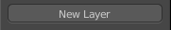
New Layer
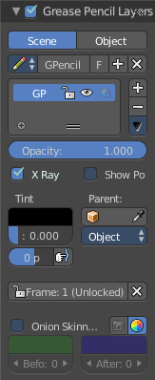
Here you can create a new layer for your grease pencil. Doing so will reveal several layer settings. And another panel with some color settings.

Layer list
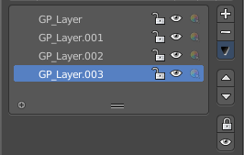
Here you can see a list of the current layers. And here you can select the current active layers.
Grease Pencil Layers can be locked (lock icon) and hidden (eye icon). The third symbol is to unprotect selected colors from further modifications.

Add / Delete
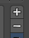
Right besides the layer list box there is a add button and a delete button. The plus button adds a new layer, The minus button removes the current layer.

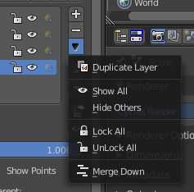
Layer Specials menu
Below the add and delete buttons there is a text menu with some further options.

Duplicate Layer
Duplicates the currently selected layer.

Show All
Unhides all hidden layers.

Hide Others
Hides all layers but the selected.

Lock All
Locks all layers.

Unlock All
Unlocks all layers.

Merge Down
Merges all layers into one.

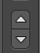
Move Up / Move down
Moves the currently selected Grease pencil layer one up or down the list.

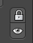
Lock Unlock unselected / Show Hide unselected
Lock Unlock unselected toggles the lock for the unselected layers.
Show Hide unselected toggles the visibility for the unselected layers.

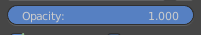
Opacity
Opacity sets the opacity of the current grease pencil stroke.

X Ray
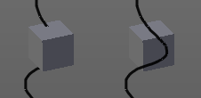
X Ray makes the grease pencil stroke appear in front of objects. Without X Ray the stroke will be invisible behind objects.

Show Points
Shows the points in the current grease pencil stroke.

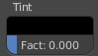
Tint
Tint tints the color of the current grease pencil stroke with the tint color.
The upper field is a color picker where you can select a color. The fac slider defines the blending factor between the grease pencil stroke color and the tint color.

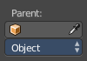
Parent
Here you can set the parent object for the current grease pencil layer

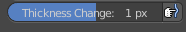
Thickness Change
Increase or decrease the thickness of the grease pencil stroke.

Lock Frame
You can draw grease pencil strokes in different frames. Here you can lock those frames from further editing.

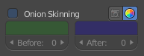
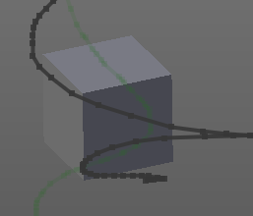
Onion Skinning
You can draw grease pencil strokes in different frames. With onion skinning you can display the strokes from the previous and following frames as ghost drawings.

Onion Skinning checkbox
Activates / deactivates the onion skinning.

Use always ghosts
When activated the ghost images will also show in rendering.

Use custom colors
Here you can choose to display the ghost drawing in predefined colors, or in their original colors. Default is to display the predefined colors.

Before
Here you can choose in which color the previous frame gets displayed. And how many frames gets displayed before the current frame.

After
Here you can choose in which color the following frame gets displayed. And how many frames gets displayed after the current frame.

Grease Pencil Colors Panel

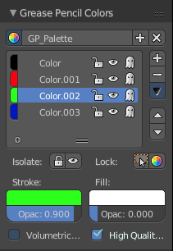
The grease pencil colors panel contains all the settings to set up and define the colors that you use for your grease pencil drawings.

It activates when you start to draw a grease pencil stroke. And shows its content then.

GP Palette
Here you can select, create and delete a color palette for the grease pencil colors. Define some colors in the Color list, then create a new palette with it.

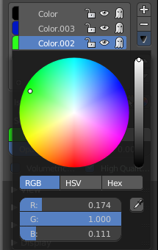
Color List
Here you can add custom colors.

The color field at the beginning of the edit box reveals a color picker when you click at it. Which allows you to define a color.

The string “Color”, “Color 002” and “Color 003” is an edit box which allows you to rename the color. Click into the field to activate it.

The Lock symbol allows you to lock the current color.

The eye symbol allows you to show or hide the current layer.

The ghost symbol allows you to display this color with onion skinning.

Add / Delete
Right besides the layer list box there is a add button and a delete button. The plus button adds a new layer, The minus button removes the current layer.

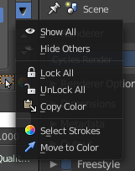
Palette color Specials menu
Below the add and delete buttons there is a text menu with some further options.

Show All
Unhides all hidden colors.

Hide Others
Hides all colors but the selected.

Lock All
Locks all colors.

Unlock All
Unlocks all colors.

Copy color
Copys the color.

Select strokes
Selects all grease pencil strokes that uses the curent color.

Move to color
Move selected strokes to active color.

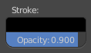
Strokecolor
Here you can define the stroke color and set its opacity.

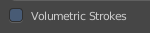
Volumetric Strokes
With Volumetric strokes the grease pencil stroke does not draw as a stroke, but a line of dotted points.
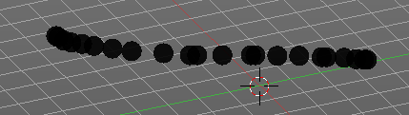

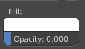
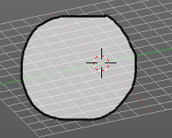
Fill
Fill fills the space between the grease pencil strokes.
The opacity is by default at zero. The fill color shows when you increase the opacity.

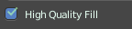
High Quality Fill
Fill Strokes uses high quality to avoid glitches. But this gives slower fps while animation. Here you can turn it off.

View panel
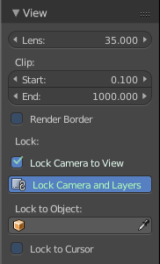
The View panel contains some camera settings for the world camera and the render camera.

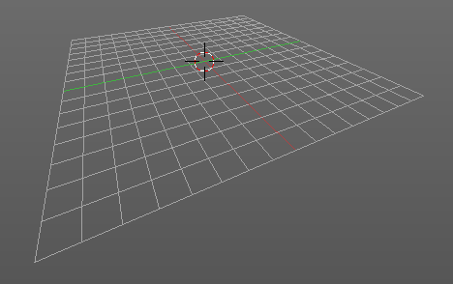
Lens
Here you can setup the lens viewport angle for the world camera. You need to be in perspectivic view. In Orthographic view the lens values doesn't have an effect.

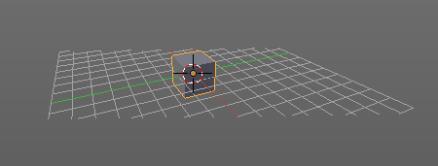
Clip
Here you can set up the clipping values for the world camera. Geometry behind the end value and before the start value will not be drawn.

Render border
When you have defined a renderborder then you can toggle it with this switch. See View menu in the 3d view header.

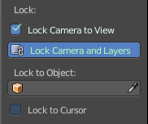
Lock section
The lock section contains some camera settings regarding locking.

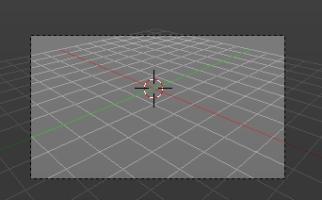
Lock Camera to view
This menu item allows you to navigate in camera view like you would be in world view. When it is unticked then you can navigate the passepartout, you can zoom and move it. And when you rotate the view, then you will leave the camera mode.

Lock Camera and Layers
This menu item also exists in the layers tab in the Tool shelf at the left.
Use the scene's active camera and layers in this view. And not local ones. When you untick this menu item then you can define a local camera below.
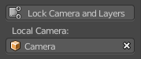

Lock to Object
Locks the view of the world camera to an object. Here you can choose an object for it.

Lock to cursor
Locks the view of the world camera to the 3D cursor. You can either lock to an object or to the 3d cursor. When you choose an object then the checkbox for the 3d cursor vanishes.

3D Cursor Panel

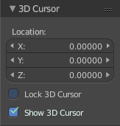
The 3d cursor panel contains the location edit boxes to display and set the 3D cursor in X, Y and Z Position. And it contains a checkbox to lock the 3D cursor.

Of interest is also the RMB menu where you can reset the 3D cursor to 0/0/0. Simply right click in one of the edit boxes and choose Reset All to default value.
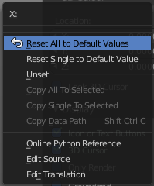

Lock 3D cursor
Locks the 3D cursor at its place.

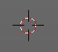
Show 3D Cursor
This checkbox can hide the 3D cursor.

Viewport Display Panel
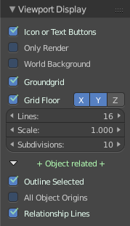
The Display panel contains various settings around the display in the current 3D view editor.

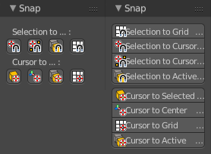
Icons or Text Buttons
The icons or text buttons checkbox defines if some of the buttons in the Tool Shelf are displayed as pure icon buttons, or as text buttons with icons.

Only Render
When ticked then just the objects that gets rendered are displayed. This option hides the groundgrid and things like relationship lines and pivot points.

Ground Grid
This checkbox can show or hide the whole Grid Floor at once. Other things like relationship lines or pivots are still displayed.

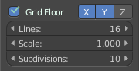
Grid Floor
The Grid Floor prop contains the settings for the Grid Floor. Number of lines, scale etc.

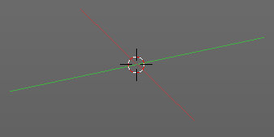
Grid Floor Checkbox
Displays or hides the grey grid of the Grid floor

X, Y Z buttons
Displays the colored orientation lines.

Lines
The Lines edit box defines how much lines the grey grid has.

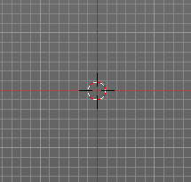
Scale
Scales the whole Grid Floor.

Subdivisions
This setting affects the orthographic views. Here you have sublines in the grey grid. And with Subdivisions you can define how much sublines a gridcell has.

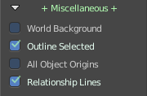
Miscellaneous subtab
The Miscellaneous subtab contains settings that you rarely use.

World Background
Show or hide the world background.

Outline Selected
Display the selected object with an outline.

All Object Origins
Display the origin of all objects in the scene. Normally just the origin of the selected object is displayed

Relationship Lines
When you have a parenting relationship, then you will see a dotted line between the parent and the child object.

Object Shading Panel

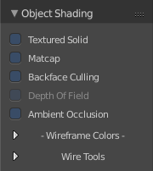
The Shading Panel contains some shading related settings. You have different settings available in different Viewport shading modes. And in different Object modes with different object types too. So best thing is to list all available options instead of going through all possible combinations in shading and object modes.

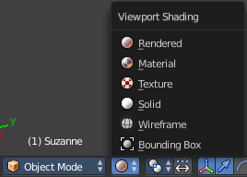

Shading Options

Backface Culling
Excludes the backfaces of the geometry from rendering.

Depth of Field
Use Depth of Field in the viewport from the active camera. Does not work with the world camera. You have to be in camera view.

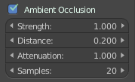
Ambient Occlusion
Use Ambient Occlusion in the viewport. When ticked some edit boxes with the Ambient Occlusion settings are revealed.

Shadeless
Displays the texture shadeless. Shows in Viewport shading Textured.

Textured solid
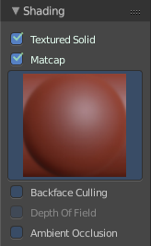
Normally the Solid shading mode doesn't display textures. With this checkbox ticked it does.

Matcap
Use Matcap Materials for solid display. Matcap stands for "material capture". It is a complete material that includes lighting and reflections. This is useful for sculpting needs for example. When you tick the Matcap checkbox then you will reveal a image field where you can choose different matcap materials.
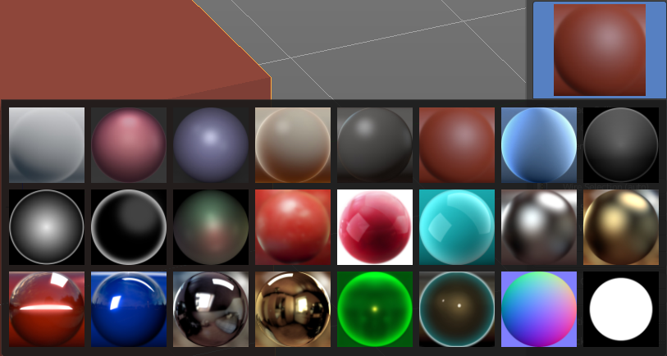

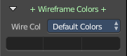
Wireframe Colors Subtab
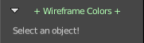
The Wireframe Colors subtab contains a toolset where you can give any objects in the viewport different wire colors. As the name says, it makes most sense when you have a mode with wireframe display selected. And you need to have a object selected. When there is nothing selected then you will get a warning.
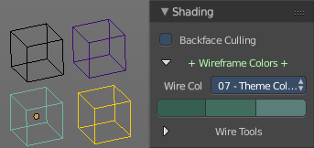
Wireframe colors works in all modes where you can have a wireframe display. Object mode, Edit Mode, Sculpt mode.
Here an example in Object mode with wireframe display.

Wire Color Set
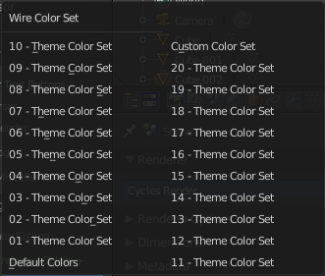
Wire Color Set is a dropdown box where you can choose between 20 predefined color sets. The colors of this color sets are not editable.

Wire colors
You can see three colors below the Wire Color Set. From left to right. The first color is the color for the object when it is not selected. The second is the color for the object when it is selected, but not the active object. The third color is the color for the object when it is selected and the active object.
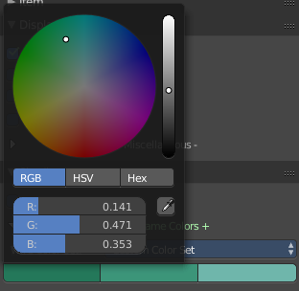

Custom color set
There is also a Custom Color Set menu item in the Wire Color Set. This one is editable. When you click at one of the color fields below the Wire Color Set, then you open up a color picker dialog where you can choose a custom color for every object.
This custom colors are saved with the scene.

Wire Tools Subtab
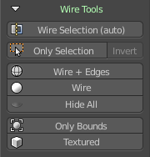
Wire Tools is an addon developed by Lapineige. You can turn it off in the addon manage if you want.
It offers a few more display mode posibilities. For example, normally you have to setup the mesh in the Properties editor to display the wireframe in Object mode. This can be done with this addon.

Wire Selection (Auto)
Display the Wire of the selection. Auto Update when selecting another object.

Only Selection
No idea. Somebody should ask the addon developer.

Invert
No idea. Somebody should ask the addon developer.

Wire + Edges
Display the Wire and Edges.

Wire
Display the Wire.

Hide All
Removes the wire display.

Only Bounds
Displays the selected object just as a bounding box.

Textured
Displays the selected object as textured.

Motion Tracking Panel

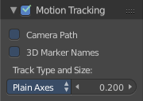
In case you do motion tracking with Bforartists, here are some options for it. Motion Tracking is another word for Motion Capture. Motion capture (in short Mo-cap) is the process of recording the movement of objects or people.
This panel can be activated an deactivated at once with the checkbox in the title.

Camera Path
Show or hide reconstructed camera path.

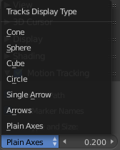
3D Marker Names
Show names for reconstructed track objects.

Track Type and Size
Here you can define the look and size of the track display type.

Background Images Panel
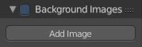
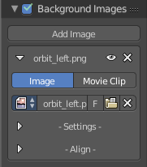
In this panel you can set up background reference images for modeling or painting needs.
The panel can be activated an deactivated at once with the checkbox in the title.

Note
Background images only shows in orthographic views. Front, back, etc.

Add Image
The Add Image button adds a new image panel to the list of background images.

Image Panel
The Image panel contains the settings and data for the background image.

Image Panel Header
The header of the image panel contains the name of the file. The eye icon hides the image from the 3D view. The X button removes the whole image panel from the list of background images.

Data Source
Here you can define if you want to load a single image, or a movie clip.

Image Edit Box
The Image icon is a dropdown box where you can choose another image or movie that is already loaded into Bforartists.
The edit box allows you to rename your image.
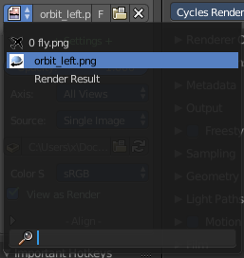
With the F button you can make this data block a fake user.
The Folder icon allows you to load another image here.
And the X button removes the image. The image panel is still there then.

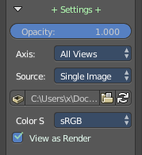
Settings Subtab

Opacity
Controls the transparency of the background image.

Axis
Choose which views the image is visible from. This is helpful when you have several reference images from different views (e.g. top, front and side).

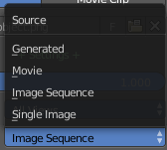
Source
Here you can choose different source types.

Single Image
Single Image doesn't have further options.

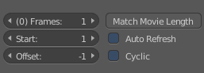
Image Sequence and Movie

Frames
Number of frames to use.

Start
The start frame.

Offset
Offset the number of the frame to use in animation.

Match Movie Length
Set the image user length to the one of the movie.

Auto Refresh
Always refresh image on frame change

Cyclic
Cycle the images in the movie.

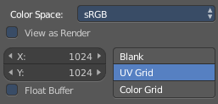
Generated
Generated doesn't use an external image, but a generated one.

Color Space
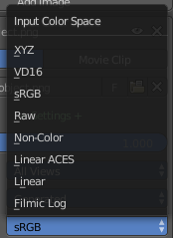
In this dropdown box you can define the color space.

View as Render
Turns on or off the color management settings in the Properties window - Possible fail entry. Shouldn't belong here.

Size edit boxes
Here you can set the size of the image

Float Buffer
Generate Floating Point Buffer. Gives a higher quality image.

Type
You can choose between three different types. Blank, UV Grid and Color.
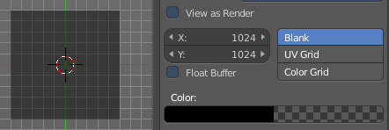
Blank is a plain color that you can define in a color picker below.

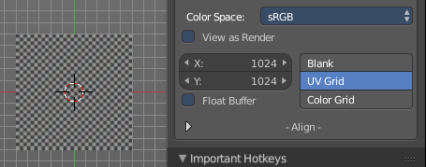
UV Grid is a black and white checker texture.

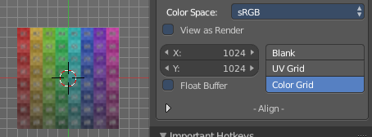
Color Grid is a colored checker texture.

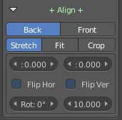
Align Subtab
This tools helps you to align the image in the view.

Back / Front
Display the image in the front of the scene objects, or behind the scene objects.

Stretch / Fit / Crop
This option is for camera view. It does not work with the world camera.
Stretch stretches the background image into the current camera view. It fills the whole view.
Fit fits the background image into the height of the current camera view. Offset parts are cut off.
Crop fits the background image into the width of the current camera view. Offset parts are cut off.

Offset Editboxes
Here you can position the image in x and y position.

Flip Horizontal
Flip the image horizontal.

Flip Vertical
Flip the image vertical.

Rotation
Rotate the image.

Size
Set the size of the image.

Transform Orientations Panel

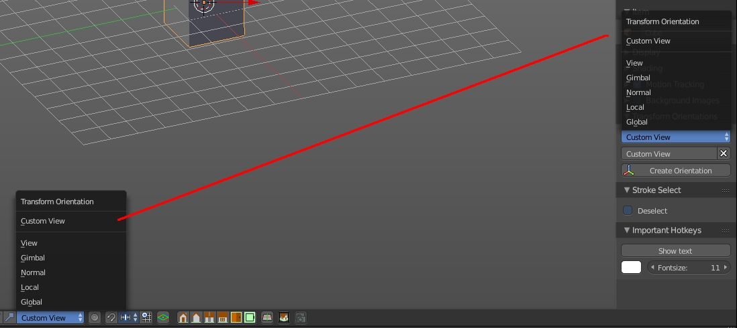
Transform Orientations allows you to create and remove a custom transform orientation, using object or mesh elements.

When such a custom transform orientations is defined from objects, then it uses the local orientation of the object. When it is defined from mesh elements (vertices, edges, faces), then it uses the normal orientation of the selection.

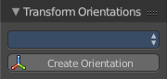
Dropdown Box with the current views.
The dropdown box with the currently available views.

Create Orientation
The create orientation button adds a new orientation from the current mode and view.

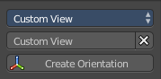
Transform Orientation Name
Here you can rename and delete the new created custom view.

Last Operator Create Orientation
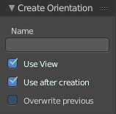

Name
Here you can rename and delete the new created custom view.

Use View
The new orientation will be aligned to the view space.

Use after creation
It leaves the newly created orientation active.

Overwrite previous
Overwrites previous created orientation.

Important Hotkeys Panel

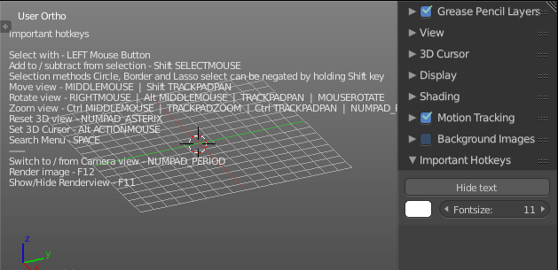
Important Hotkeys is an addon. It displays the most important hotkeys as strings in the viewport.

This addon can be deactivated and uninstalled from the User Preferences in case you don't need it anymore.

Show Text / Hide Text
Shows or hides the text.

Color
Here you can set the color of the font.

Fontsize
Here you can set the size of the font.

Item Panel

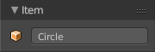
When you have an object in the scene then you will see the Item panel.

This edit box shows the name of the current selected item. And here you can also rename the item.

Stroke Select Panel
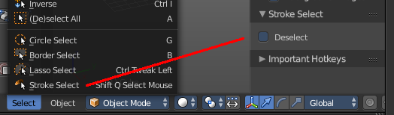
Stroke select is an addon. You can switch between select and deselect with the right mouse button. This panel is the visual end to show you in which mode you currently are.

Transform Panel

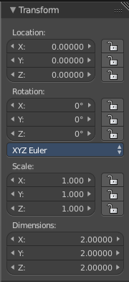
The transform panel shows you the transform values. The content depends of what object you have chosen, and in what mode you are. In Edit mode you may have other transform values than in object mode. Non Primitive objects doesn't have a edit dimensions box, and so on.

In Object Mode

Location
The location edit boxes. Here you can see and set the position of the selected object. The lock symbol behind the edit boxes allows you to lock the axis position

Rotation
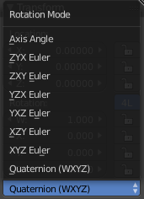
The Rotation edit boxes. Here you can see and set the rotation of the selected object. The lock symbol behind the edit boxes allows you to lock the axis rotation.

Rotation mode
Rotation mode is a dropdown box where you can choose between different rotation modes.

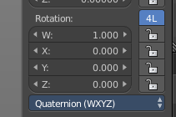
Euler angles gets calculated with three values. Quaternions with four angles. And so you get a fourth angle value when you choose Quaternions as the rotation mode.
The 4L button allows you to lock out the fourth component from editing.

Scale
The Scale edit boxes. Here you can see and set the scale factor of the selected object. The lock symbol behind the edit boxes allows you to lock the axis scale.

Dimensions
The Dimensions edit boxes. Here you can see and set the dimensions of the selected object in world coordinates. The lock symbol behind the edit boxes allows you to lock the axis rotation.
The Dimensions edit boxes are just available for primitives objects. Objects like Empties or a Camera doesn't have a dimension, but a scale factor.

In Edit Mode
Just primitive objects does have an edit mode. Non primitive objects like a camera or an empty doesn't have an edit mode. With two exceptions. Text and Force Field type Curve Guide. Both are curve types.
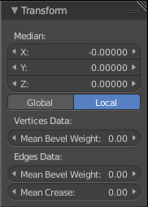

Mesh Objects

Median
Median is the position of the selected mesh part

Global / Local
Here you can define if the orientation of the selection is local to the selected object, or global to the world coordinates.

Mean Bevel Weight - Vertices Data
Here you can adjust the bevel weight for the selected vertices when you have a bevel modifier at the mesh.

Mean Bevel Weight - Edges Data
Here you can adjust the bevel weight for the selected edges when you have a bevel modifier at the mesh.

Mean Crease
Here you can adjust the weight of the selected vertices when you have a subdivision surface modifier at the mesh.

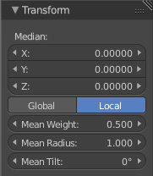
Curve Objects / Surface Objects

Median
Median is the position of the selected mesh part

Global / Local
Here you can define if the orientation of the selection is local to the selected object, or global to the world coordinates.

Mean Weight
Here you can adjust the weight used by softbody. Needs softbody.

Mean Radius
Here you can adjust the radius of the curve control points

Mean Tilt
Here you can adjust the tilt of the curve control points.

Metaball Objects

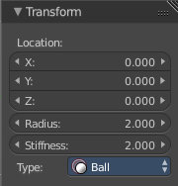
Median
Median is the position of the selected mesh part

Global / Local
Here you can define if the orientation of the selection is local to the selected object, or global to the world coordinates.

Radius
Here you can adjust the radius of the selected meta element.

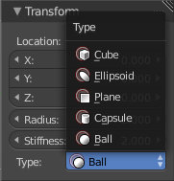
Stiffness
Here you can adjust the stiffness of the selected meta element.

Type
Type is a dropdown box. Here you can adjust the meta element type.

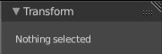
Text Objects
Text objects do have an edit mode, but they don't show content in the Transform panel.

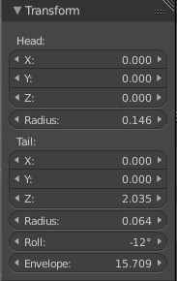
Armature objects Edit Mode
Bones do have a head and a tail. You cannot position the whole bone by numeric values, but the head and tail joints.

Head
Here you can adjust the world position of the head joint.

Radius
This is just useful when you use Envelopes type bones. Here you can adjust the Envelope radius of the head joint.

Tail
Here you can adjust the world position of the tail joint.

Radius
This is just useful when you use Envelopes type bones. Here you can adjust the Envelope radius of the tail joint.

Roll
Here you can adjust the bone roll.

Envelope
This is just useful when you use Envelopes type bones. Here you can adjust the overall Envelope size.

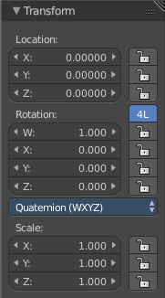
Armature Objects in Pose Mode
The content in Pose mode is the same than in Object mode. We have Location, Rotation and Scale Edit Boxes. And the corresponding lock buttons.
Wiht one small difference. The rotation mode starts with Quaternions by default. And not with Euler Angles.

Lattice Objects
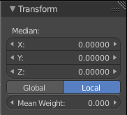
You need to have some vertices of the Lattice object selected to see the content.

Vertex
Here you can see and set the vertex positions of the lattice objects.

Global / Local
Here you can define if the orientation of the selection is local to the selected object, or global to the world coordinates.

Mean Weight
Lattice object is a deform cage. Here you can adjust the mean weight of the selected vertice(s).

Mesh Display Panel

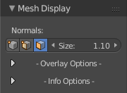
This panel just shows in Edit mode with a mesh object selected. It contains some mesh related display settings like normals, or that you can display the length of an edge.

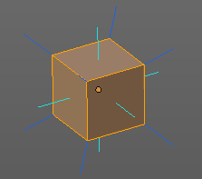
Normals
Here you can display the vertex, edge and faces normals at the selected mesh. The size box allows you to adjust the length of the stroke that displays the normal.

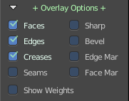
Overlay Options subtab
This subtab contains various display settings.

Faces
Displays selected faces with the orange select color.

Edges
Displays selected edges with the orange select color.

Creases
Displays Creases.

Seams
Displays marked seams.

Show Weights
Shows the weights of the vertices.

Sharp
Shows as sharp marked edges.

Bevel
Shows Beveled edges.

Edge Marks
Shows Edge Marks.

Face Marks
Shows Face marks.

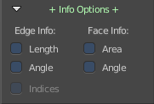
Info Options subtab
The info Options subtab contains some settings with which you can display additional informations at the mesh geometry. The values are in world coordinates.

Edge Info

Length
Displays the length of the selected edges.

Angle
Displays what angle the adjacent faces of the selected edges has.

Face Info

Area
Displays how big the area of the selected faces is.

Angle
Displays what angle the adjacent faces of the selected edges has.

Indices
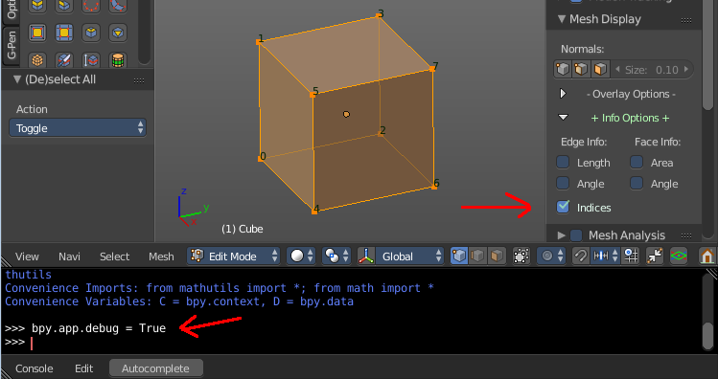
Indices is a special debug feature for programmers and developers. Sometimes the order of the mesh elements counts. With this option ticked you can display the indices of the mesh elements in the viewport.
This feature is deactivated by default. You first need to activate it in the Python console by activating the Debug mode. Type in 'bpy.app.debug = True', and hit enter . Then tick the Indices checkbox. And then you can see the values for the selected elements at the mesh.
When you are in Vertices mode then the indices numbers for the vertices gets displayed. When you are in Edge mode, then the indices for the Edges gets displayed. And when you are in Face mode, then the Face indices gets displayed.

Mesh Analysis Panel
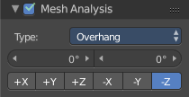
The Mesh Analysis is to analyze mesh attributes for 3D printing. For example, Some 3D printers have a physical limit to the overhang that can be printed. Or it needs a specific thickness.

The Mesh Analysis panel just shows in Edit mode with a mesh object selected. And in Solid Mode. Furthermore you need to have a Deform modifier at the mesh. You can activate and deactivate the whole panel at once in the header.

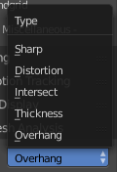
Type dropdown box

Here you can choose between the different methods of analysis

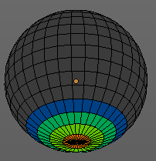

Overhang
Calculates and displays the overhang areas.

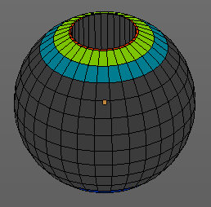
Thickness
Calculates and displays the thickness.

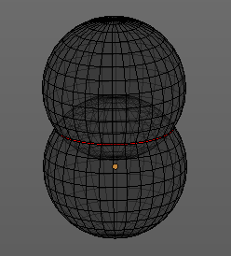
Intersections
Displays intersecting faces in red. This mode has no settings.

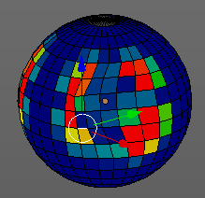
Distortion
Displays non planar quads and n-gons dependant of a given angle.

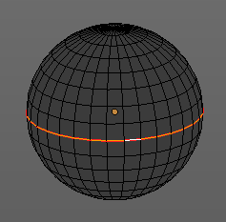
Sharp Edges
Similar to wall-thickness, sharp edges can form shapes that are too thin to be able to print.

Angle
Here you can adjust the angle for the calculation

Axis
Here you can choose the axis that should be calculated.

Curve Display Panel
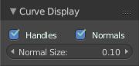
Here you can find some display settings for Curve objects.

This panel is just visible with a Curve Object in Edit Mode.

Handles
Display the handles at the curve object.

Normals
Display the normals at the curve object.

Normal Size
Adjust the size of the normals at the curve object.

Skeleton Sketching Panel
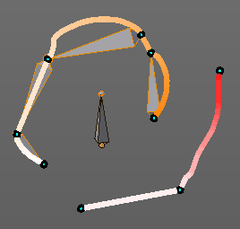
This is a tool, and should belong into the tool shelf. For now it's in the Properties.

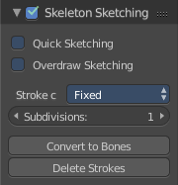
Skeleton sketching allows you to paint your skeleton with strokes instead of extruding out bones. Every point becomes a joint then. And when you click the convert button, then the armature gets created.

The Skeleton sketching panel is just visible in Edit mode with an Armature object.

To activate and deactivate this tool simply tick the checkbox in the header of the panel. Then you will be able to paint strokes in the viewport. Right click to end a stroke.

Quick Sketching
Automatically convert the strokes to bones when you end the stroke.

Overdraw Sketching
With this option ticked you can adjust strokes by painting near them.

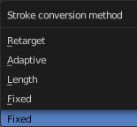
Stroke Conversion method
Here you can choose between different conversion methods.

Retarget
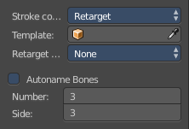
This method is unfortunately not documented in the Blender manual, it is listed as Todo. And it is not to find out how this is meant to work.

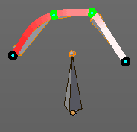
Adaptive
Draws bones in the average length of the stroke, but tries to follow the shape of the stroke.

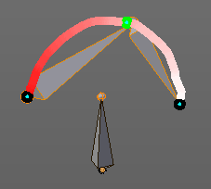

Length
Draws bones in the average length of the stroke.

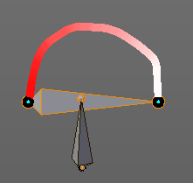
Fixed
Draws bones between the points in the stroke.

Convert to bones
Converts the current strokes into an armature.

Delete Strokes
Deletes all strokes from the viewport.

